
Department of BES-1
DATA STRUCTURES THROUGH PYTHON(24SC1204)
I/IV-B.Tech-(II Sem), Academic Year: 2024-2025

Session-37 (Graph Traversal Techniques)
Instructional Objective:
- To learn the concept of Graph traversal techniques
Learning Outcomes:
1. Students come to know about graph traversal – DFS
Introduction:
Graph traversal is a technique used for a searching vertex in a graph. The graph traversal is also used to decide the order of vertices is visited in the search process. A graph traversal finds the edges to be used in the search process without creating loops. That means using graph traversal we visit all the vertices of the graph without getting into looping path.
There are two graph traversal techniques and they are as follows...
- DFS (Depth First Search)
Explanation:
DFS traversal of a graph produces a spanning tree as final result. Spanning Tree is a graph without loops. We use Stack data structure with maximum size of total number of vertices in the graph to implement DFS traversal.
Steps to implement DFS traversal...
Step 1 - Define a Stack of size total number of vertices in the graph.
Step 2 - Select any vertex as starting point for traversal. Visit that vertex and push it on to the Stack.
Step 3 - Visit any one of the non-visited adjacent vertices of a vertex which is at the top of stack and push it on to the stack.
Step 4 - Repeat step 3 until there is no new vertex to be visited from the vertex which is at the top of the stack.
Step 5 - When there is no new vertex to visit then use back tracking and pop one vertex from the stack.
Step 6 - Repeat steps 3, 4 and 5 until stack becomes Empty.
Step 7 - When stack becomes Empty, then produce final spanning tree by removing unused edges from the graph

Example
Consider the following example graph to perform DFS traversal
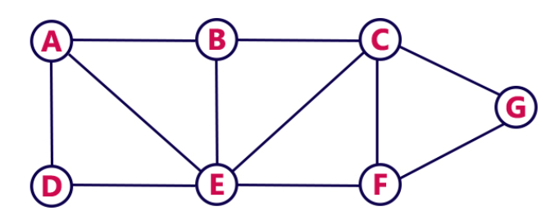
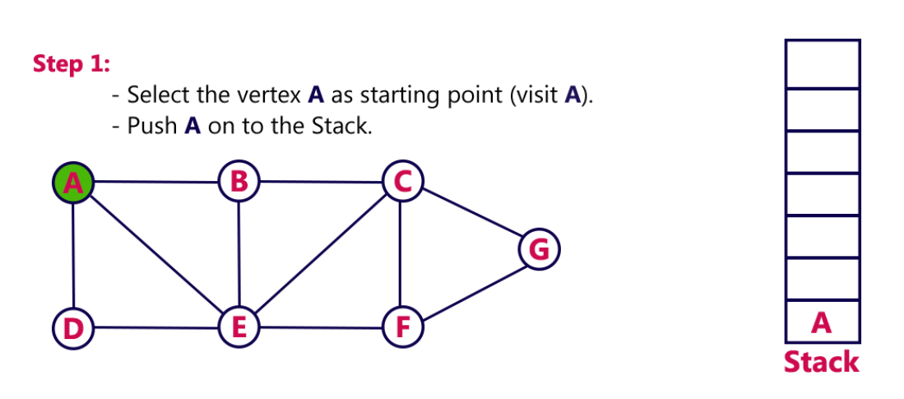
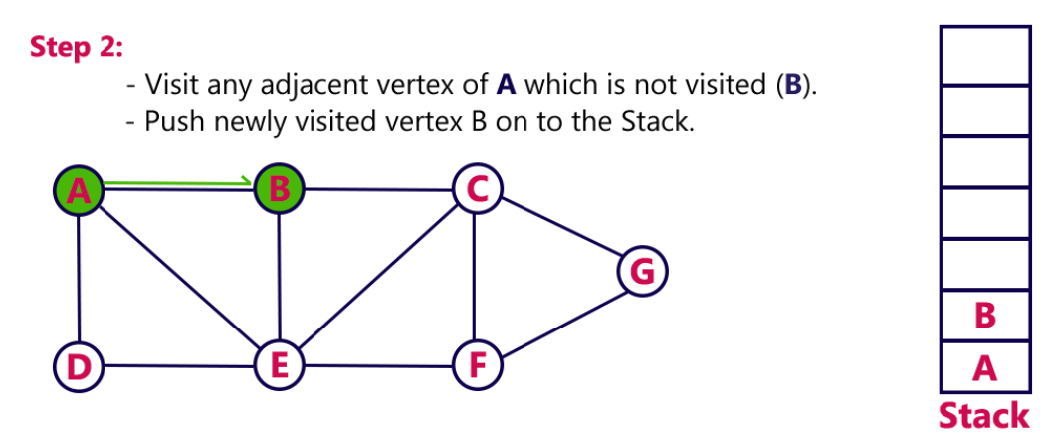
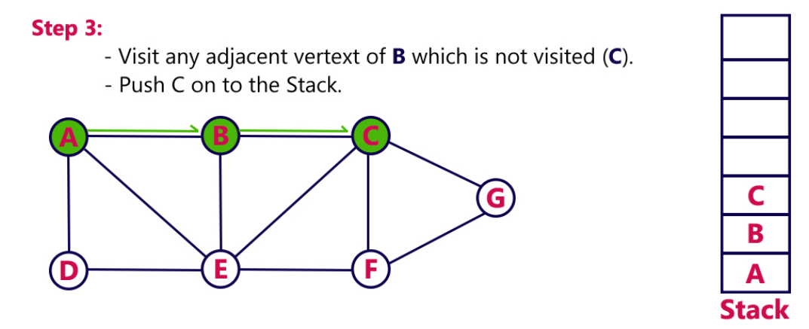
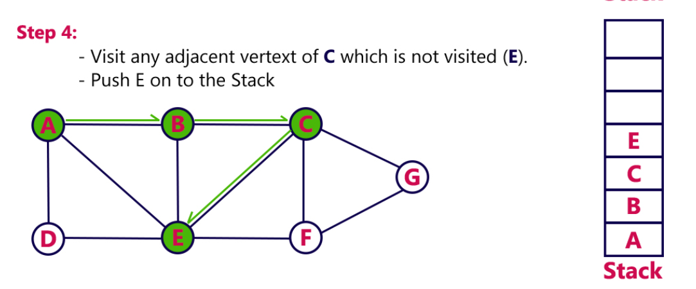
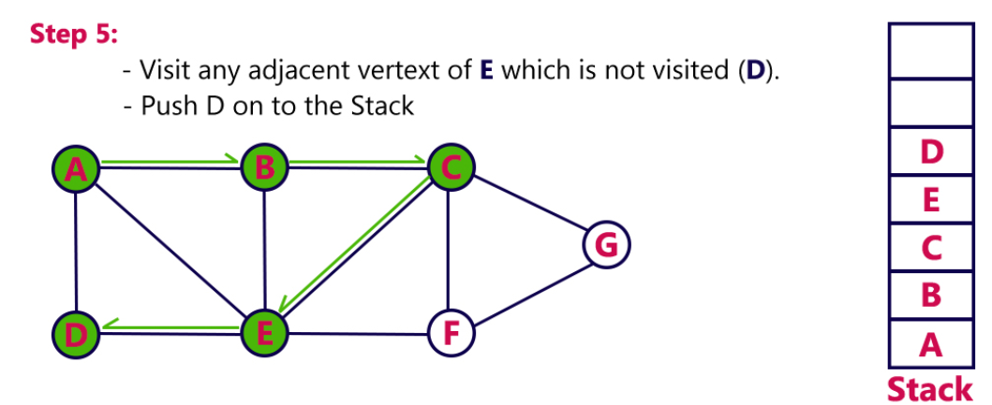
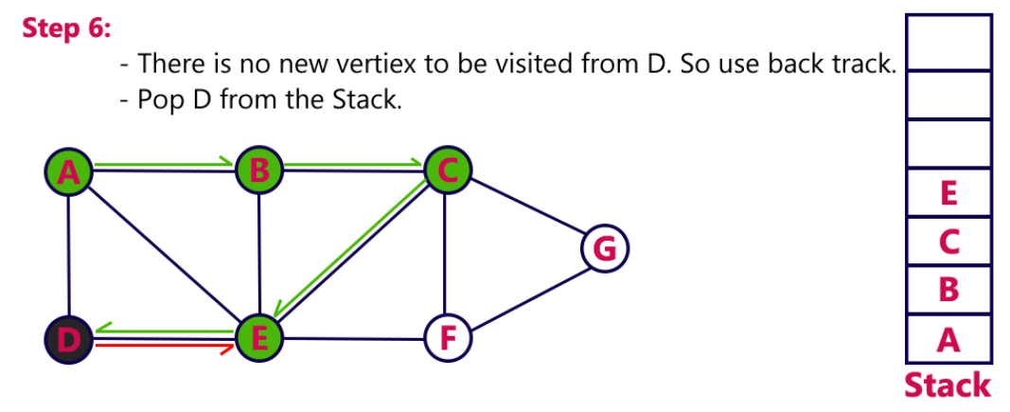

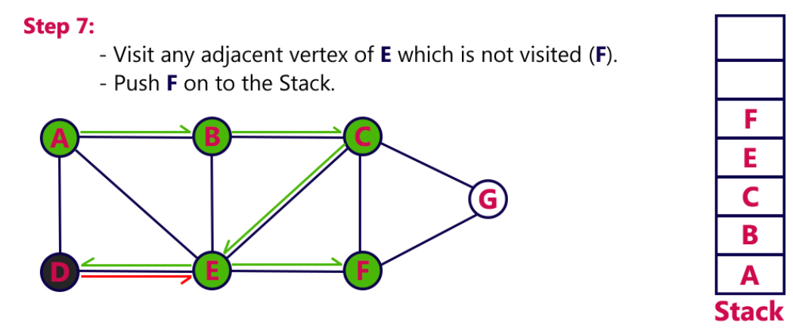
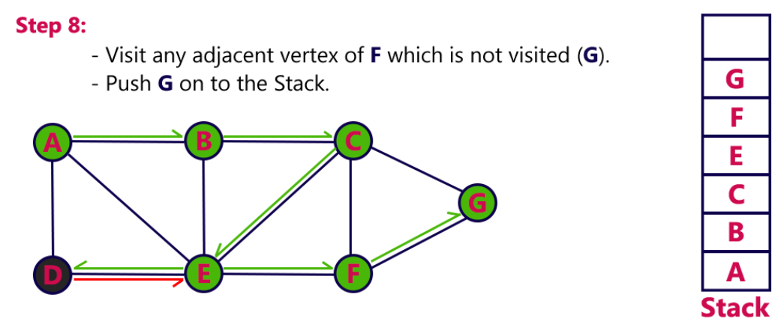
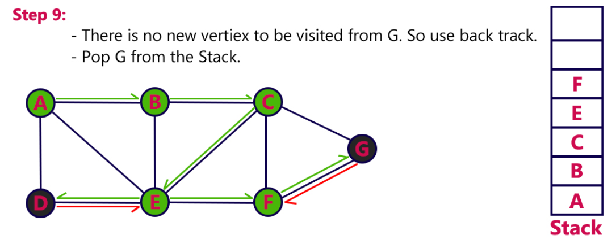
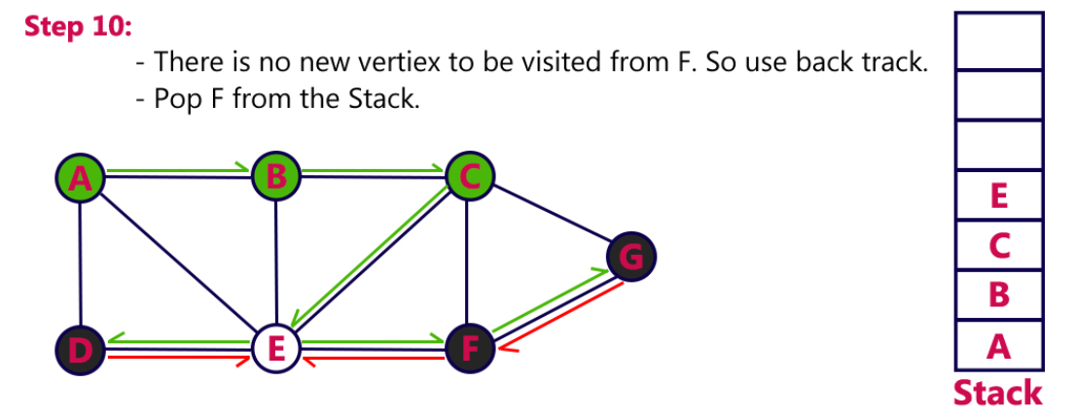

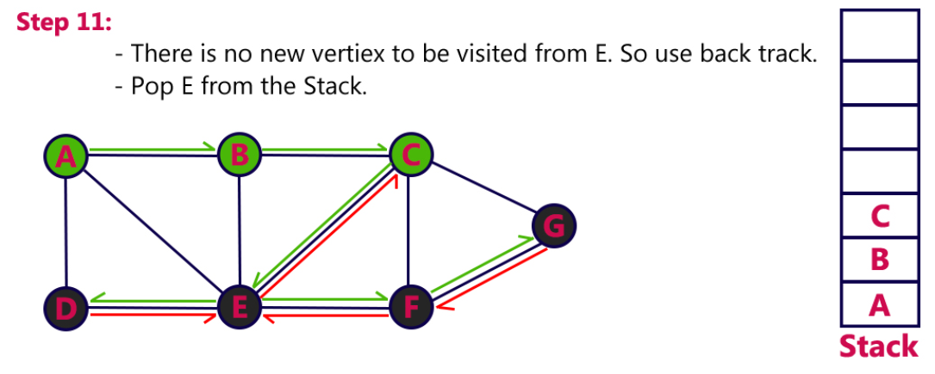
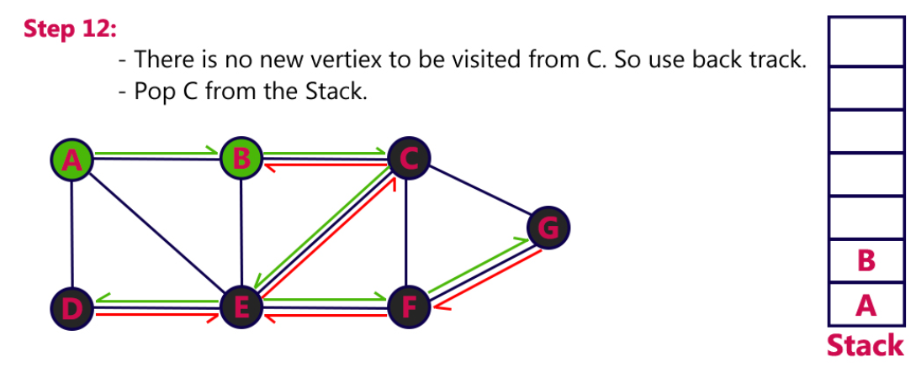
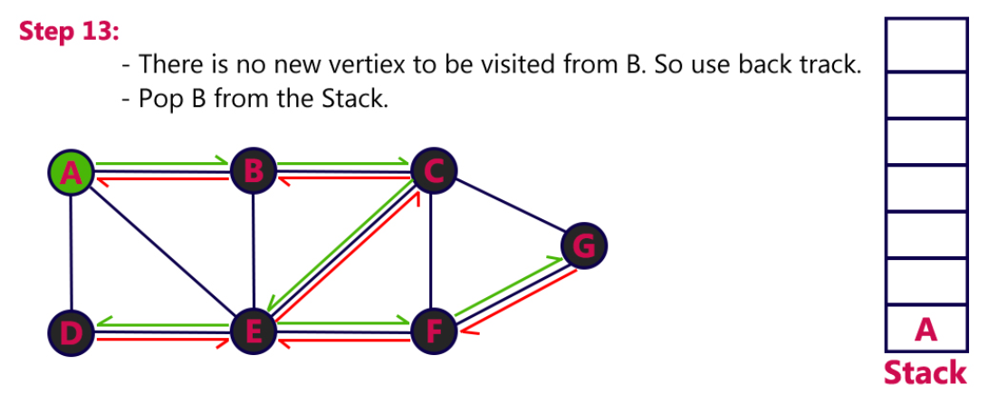
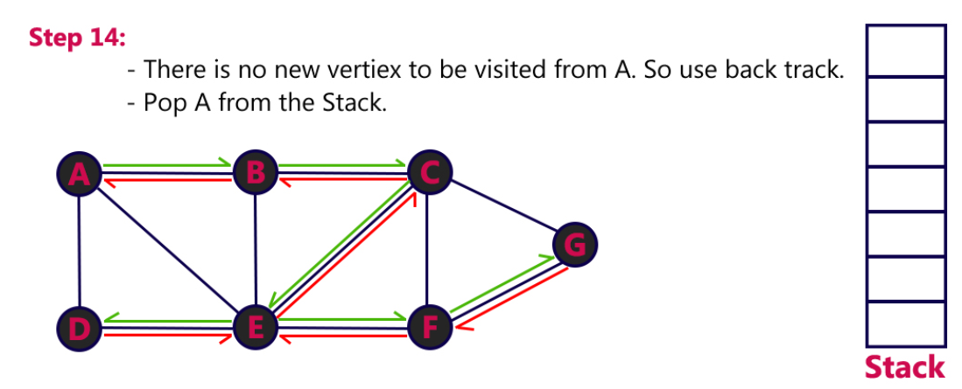
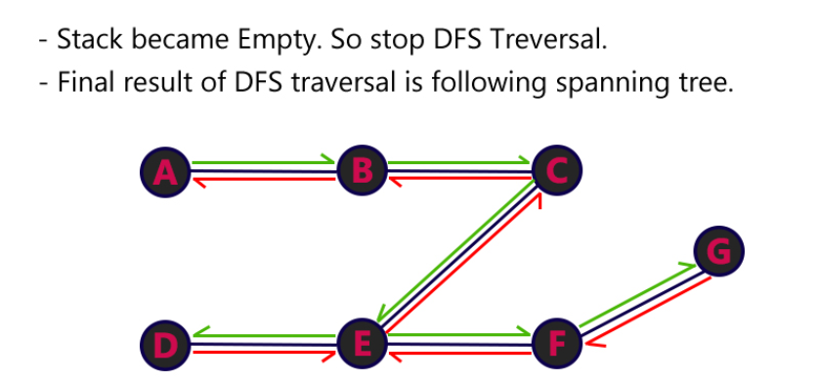
Review questions:
- What is DFS?
- How queue and stacks are implemented?

Summary:
In this session, it was discussed about how to traverse a graph using DFS
Self-assessment questions:

1. Breadth First Search is equivalent to which of the traversal in the Binary Trees?
a) Pre-order Traversal
b) Post-order Traversal
c) Level-order Traversal
d) In-order Traversal

Answer:-C

2. Time Complexity of Depth First Search is? (V – number of vertices, E – number of edges)
a) O(V + E)
b) O(V)
c) O(E)
d) O(V*E)
Answer: - A
Terminal questions

PRACTICE PROBLEMS
- Find DFS for the given graph

